To get this Project opened properly, first open the Scene named GradWork.

When the Scene opens you should see this 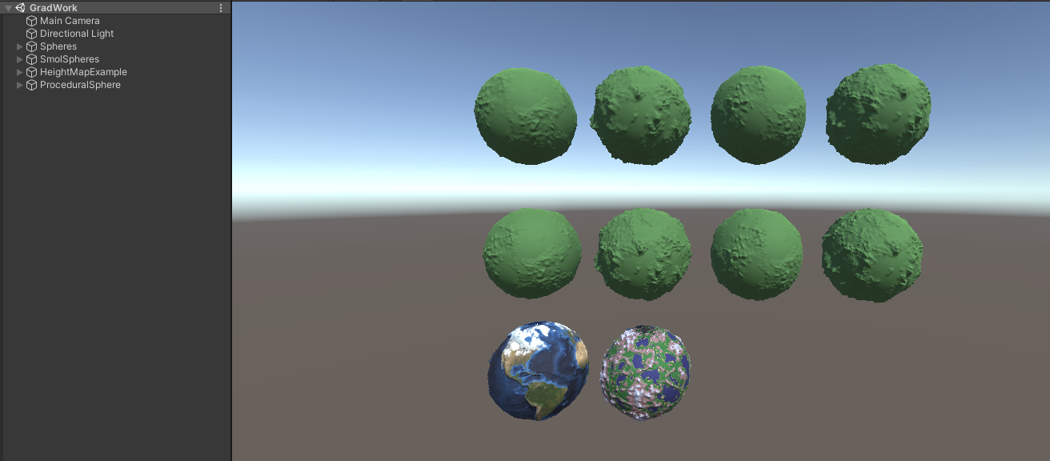

!ATTENTION!,

your graphics card is probably getting old or tired, just like mine. The solution to this is to

what it currently is, to (16,16,1) or (8,8,1) or something along those lines. That should fix the problem. But the drawing to textures will no longer work as expected. Consider running the project on a better computer. !ATTENTION! thank you. Please continue.

The Two bottom spheres are HightmapExample and ProceduralSphere respectively.

this should regenerate the meshes, if that does not work. Delete the meshes and toggle it on and off again. This is the generall rool for all the shapes.

If for some reacon the spheres are green, you can fixthat by unticking UseMaterial, and toggling  on and off. This setting is best kept of when adjusting spheres. As the Color_ComputeShader is a slight bit heavy for meshes with a lot of vertices.

These spheres are the main project.

They start like this. and flick the  that can be found at the botom of the inspector.

Furthermore, make sure the reset is off on all spheres unless you ned to force a mesh too regenerate .

Thesse are tehe settings that will adjust the spheres.